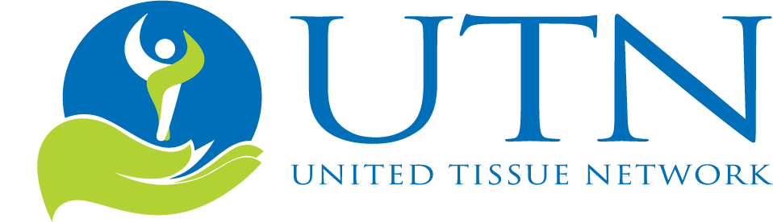

Sample Social Media Posts

Facebook/Google+: With [Company Name] you can choose to make a difference for the lives of tomorrow by selecting our whole-body donation package with UTN. Learn more: [Link]

Facebook/Google+: [Company Name] supports medical advancements to enhance everyday lives. Learn how you can too, through whole-body donation. [Link]
Facebook/Google+: Are you interested in learning how you can make a difference? Our services provide an option to enhance everyday lives. Learn more: [Link]
Twitter: We honor those who wish to make a difference at end-of-life. Learn more about our whole-body donation service: [Link]
Twitter: Do you wish to support medical professionals who are advancing technology, training and education? See our services here: [Link]

